# **Tree Worksheet**

# **Binary Trees**

Insert the following numbers into this balanced tree: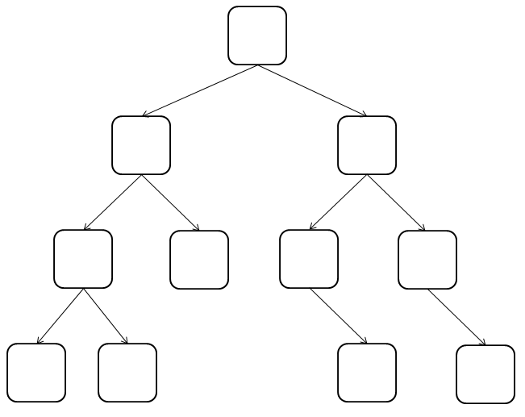

fill in numbers so the tree is balanced and so the highest number on the top and to the right and lowest 

1. 64

2. 23

3. 15

4. 79

5. 4

6. 67

7. 44

8. 99

9. 17

10. 72

11. 100

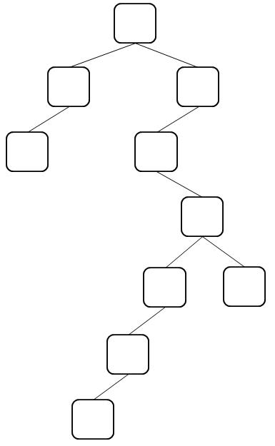

Insert the following numbers into this unbalanced tree. (Notice that though the data is the same, they’re in a different order than the first tree)

1. 17

2. 100

3. 23

4. 79

5. 67

6. 99

7. 72

8. 64

9. 15

10. 4

11. 44